**Underground Temple:**

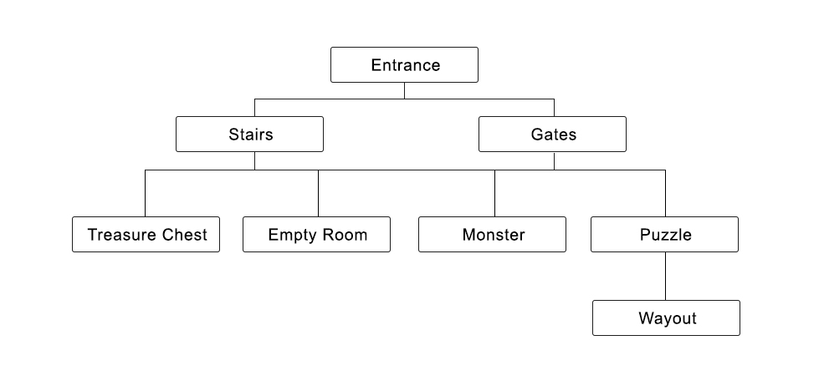

#1 On the far edge of the forest, a steep rocky wall raises high above the trees. You found an entrance surrounded by sculptures of fish like creatures. (Option: Explore inside Or Leave this place)

#2 Explore inside 🡪 A narrow spiral staircase leads you deeper in the darkness (Option: Upstairs Or Downstairs)

#2 Explore inside 🡪 Two big gates with distinct looking to each other in front of you (Option: Left gate or Right gate)

#2 Leave this place 🡪 Nothing happen, END of QUEST

#3

|  |  |  |  |
| --- | --- | --- | --- |
| Upstairs | Downstairs | Left gate | Right gate |

No matter what you choose: Upstairs, Downstairs, Left gate or Right gate, they will randomly lead you to following events in loop until you find the way-out of the Temple 🡪

#3 Treasure Chest:

A room with a sliver chest on the floor (Option: Open it or Open it)

#3 Empty Room:

An ordinary empty room with thick stone wall. (Option: Break the wall or leave)

If you have Hammer, you can break the wall successfully.

#4 Empty Room:

Break the wall🡪 A small chamber appeared where you find a Gold Goblin. (Option: Hit it or ask it Gold nicely)

#3 Encounter Monster:

A fishy kind of monster appear to you, you are forced to battle with it (Option: Physical Attack or Magic Attack)

#3 Puzzle Room:

A green eyes fish creature statue holding a crystal ball with two sockets, and on the floor there are three kind color balls: red, blue and yellow for you to put in.

#4 Puzzle Room:

Do you want to put Red ball? (Option: Yes or No)

Do you want to put Blue ball? (Option: Yes or No)

Do you want to put Yellow ball? (Option: Yes or No)

The answer is to put Blue and Yellow ball, if do it wrong…then the floor collapse, you die…Gameover

If you successfully clear the puzzle, then go #5

#5 Puzzle Room:

Clear the puzzle 🡪 You have obtain a green gem (function: xxxx), and the platform raised a secret dark path appeared to you (Option: Go in or Go in)

#6 Puzzle Room

Go in 🡪 You are in dark but you feel both wind and light are summoning you to the wayout in different direction (Option: go to the light or go to the wind)

#7 Puzzle Room

Go to the light 🡪 It is an illusion, the fish boss’s lantern caught you attention, you are too weak to fight such legendary creature, it consumed you …Game over

#7 Puzzle Room

Go to the Wind 🡪 it is the wayout